Project Proposal on

**Online Food Ordering System**

**By**

**Tooga Garanja Magar**

NCC ID: 00175867

Softwarica College of IT and E-Commerce

Dillibazar, Kathmandu

Table of Contents:

Contents

Table of Figures: 2

Chapter 1: 3

1.1 Introduction: 3

1.2 Background: 3

1.2.1. Problem Statement: 3

1.3 Justification: 3

1.4 Overview: 3

Chapter 2: Scope: 3

2.1 Aims: 3

2.2 Objectives: 3

2.3 Features: 4

2.4 Overview: 4

Chapter 3: Development Methodology: 4

3.1: Methodology used: 4

3.2: Design Pattern: 5

3.3 System Architecture: 6

Chapter 4: 8

4.1: Work Breakdown Structure: 8

4.2: Milestones: 9

4.3: Gantt chart: 10

Chapter5: 11

5.1: Risk Management: 11

Chapter 6: Configuration Management: 13

6.1: 13

Chapter 7: Conclusion: 14

References: 14

# Table of Figures:

Figure 1: Waterfall Methodology 4

Figure 2 MVC Design pattern 6

Figure 3 3-Tier Architecture 7

Figure 4 Work Breakdown Structure 8

Figure 5 Scheduling of the project 10

Figure 6 Gantt Chart 11

Figure 7 : Tree Structure of the Folder structure 13

Figure 8 Folder Structure in Github Drive 14

# Chapter 1:

## 1.1 Introduction:

With the developing technologies, in this digital era, the needs of the people are increasing rapidly. As these technologies have made the lifestyle of an individual efficient and easily available at any time anywhere. The presence of such system has a great role in day to day life.

Online Food Ordering System is a web based application providing easy access with a purpose to help customer order the varieties of food they want to eat without having them to go to restaurants by themselves. They can order the food they want which is separated through cuisine types and select from item that is available.

## 1.2 Background:

This system help customers to order food online according to their choice.

Previously, there were no such system, rather they were based on ordering the items on the phone which was problematic. There was a gap in the visual confirmation between what costumer want and what was delivered to them.

### 1.2.1. Problem Statement:

The problem faced by the current system was delay in the delivering of food that lead to customer dissatisfaction. There was manual system where customers have to wait in the line to make their order. Having submitted their request, the client should then hold up close to the counter until their request is prepared for gathering.

So, once the system is made, it will provide access to order the food by an automated process. Customer can see the available food items and can place their order. This permits restaurant employees to rapidly experience the requests as they are set and produce the vital items with negligible deferral and confusion.

## 1.3 Justification:

This project is being made to create a system where customers can visit the site and look after the food, view their price and order what they like. And also provide their reviews on certain food they have ordered.

It is applicable to make this system as it will impact the people who don’t have time by giving them affordable healthy foods.

## 1.4 Overview:

The proposed system will let the users to order food, provide reviews on the respective items according to their choices.

# Chapter 2: Scope:

## 2.1 Aims:

The main aim of the project is to provide a platform to the users where they can order food online and deliver them on time.

## 2.2 Objectives:

1. To design a platform that will satisfy the user by its service.

2. To develop a software that will allow numerous order at a time.

3. To reduce the time that might take for ordering.

4. To create a simple system that will be applicable to use for everyone.

5. To make a user friendly environment that will increase user efficiency.

6. To evaluate its introduction and appropriateness with respect to security, usability, exactness and resolute quality.

## 2.3 Features:

1. Admin can manage orders and can add, remove food items.

2. Customers can place order of food from menu by visiting the website.

3. They can give reviews.

4. The website is made user friendly.

5. The platform is interactive as well as responsive.

## 2.4 Overview:

The scope of project is to provide a responsive platform that will let the users to interact with the food items they want to order.

# Chapter 3: Development Methodology:

## 3.1: Methodology used:

The Waterfall Methodology is the primary Process Model to be presented. It is additionally alluded to as a straight successive life cycle model. It is extremely easy to comprehend and utilize.

The steps that need to include in this methods are:

* Feasibility Study.
* Analysis
* Design
* Implementation
* Testing
* Maintenance

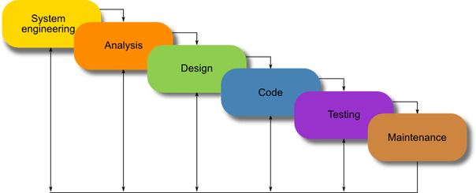

Figure 1: Waterfall Methodology

Reasons to use this methodology:

•As every one of the stage has explicit convey dates and audits, it is anything but difficult to deal with the models.

•Waterfall model is straightforward and straightforward.

•Steps are not overlapped.

•The achievement is high if the prerequisites are surely known.

## 3.2: Design Pattern:

**MVC (Model View Controller**) is a plan design for PC programming. It tends to be viewed as a way to deal with recognizing the information model, controlling data and the UI. It flawlessly isolates the graphical interface showed to the client from the code that deals with the client activities. The goal is to give a structure which implements better and progressively precise plan.

**1. Model:** The model addresses an entity that is unique - it could be a single article or practically certain a structure. There is an organized relationship with the substance and the article's data. The model responds to requesting beginning from the view regarding its status or state. Thusly, the treatment of data happens just in the model, which ensures internal data consistency.

**2. View:** The view is utilized to display the graphical perception of the UI. It could sift through certain parts of the model or feature others. It speaks to the info and yield information in an interface utilizing different components, for example, pushbuttons, menus, discourse boxes, and so forth. To see the status of the application protests, the view inquiries the model through the controller.

**3. Controller:** The controller gives the connection between the UI (see) and the application handling rationale (model). The controller utilizes the model strategies to recover data about the application object, to change the status of the article and to illuminate the view about this change. It might be said the controller empowers a client to make changes and get results.

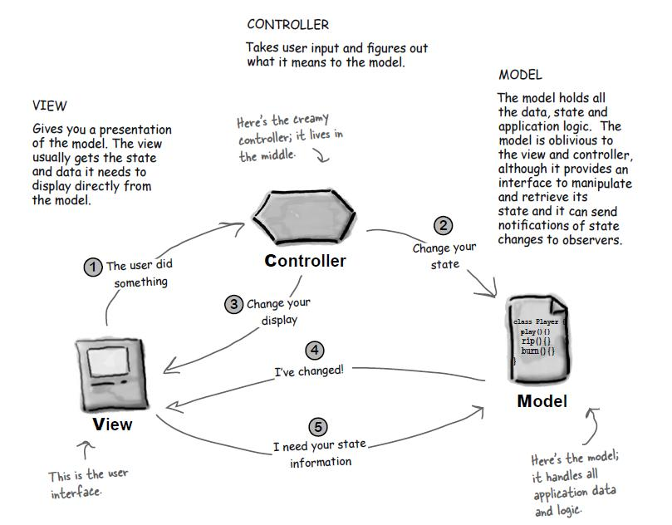

Figure 2 MVC Design pattern

## 3.3 System Architecture:

**3-Tier Architecture:**

A three-tier design is a customer server engineering in which the utilitarian procedure rationale, information get to, PC information stockpiling and UI are created and kept up as autonomous modules on discrete stages. Three-level engineering is a product configuration design and an entrenched programming design.

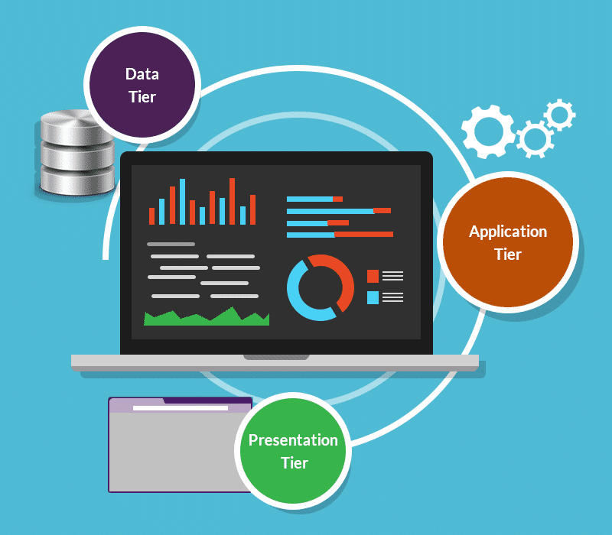

Figure 3 3-Tier Architecture

**1. Presentation Tier:** It occupies the top level and shows data identified with administrations accessible on a site. This level speaks with different levels by sending results to the program and different levels in the system.

**2. Application Tier:** Also called the center level, rationale level, business rationale or rationale level, this level is pulled from the introduction level. It controls application usefulness by performing point by point handling.

**3. Information Tier:** Houses database servers where data is put away and recovered. Information in this level is kept autonomous of utilization servers or logics of business.

# Chapter 4:

## 4.1: Work Breakdown Structure:

A work breakdown structure (WBS) is a key undertaking deliverable that sorts out the collaboration into reasonable segments. The Project Management Body of Knowledge (PMBOK) characterizes the work breakdown structure as a "deliverable arranged progressive disintegration of the work to be executed by the venture group." The work breakdown structure outwardly characterizes the extension into sensible pieces that a task group can comprehend, as each degree of the work breakdown structure gives further definition and detail.

Online food ordering system

Project

Management

Documentation

Analysis

Testing

Implementation

Design

\

Unit testing

Requirements Specification

User interaction

Structural Diagram

Introduction

Database Building

Final Description

White-box testing

Scope

Management

Diagram

Development methodology

Black box testing

Coding

Behavioral Diagram

Project

Planning

Architecture

Database design

Validation test

Risk management

Analysis specification

UI design

Configuration Management

Submission

Figure 4 Work Breakdown Structure

## 4.2: Milestones:

It signifies the particular point in a development. Here, we are going be setting introductory dates and due dates of the ventures by sub-dividing it into distinctive little modules.

|  |  |
| --- | --- |
| MILESTONE | DATE |
| **Proposal** | 6/16/2019 to 7/01/2019 |
| Introduction | 6/16/2019 to 6/19/2019 |
| Scope Management | 6/20/2019 to 6/22/2019 |
| Development Methodology | 6/23/2019 to 6/25/2019 |
| Project Planning | 6/26/2019 to 6/27/2019 |
| Risk Management | 6/28/2019 to 6/28/2019 |
| Configuration Management | 6/29/2019 to 6/30/2019 |
| Conclusion | 7/1/19 to 7/1/2019 |
| **Analysis** | 7/2/2019 to 7/29/19 |
| Requirement Analysis | 7/2/2019 to 7/8/19 |
| Diagram | 7/9/19 to 7/15/19 |
| Architecture | 7/16/19 to 7/22/19 |
| Analysis Specification | 7/23/19 to 7/29/19 |
| **Design** | 7/30/19 to 8/29/19 |
| Structural Diagram | 7/30/19 to 8/6/19 |
| Behavioral Diagram | 8/7/19 to 8/13/19 |
| UI design | 8/14/19 to 8/21/19 |
| Database design | 8/22/19 to 8/29/19 |
| **Implementation** | 8/30/19 to 9/20/19 |
| Database building | 8/30/19 to 9/7/19 |
| Coding | 9/8/19 to 9/20/19 |
| **Testing** | 9/21/19 to 9/30/19 |
| Unit testing | 9/21/19 to 9/22/19 |
| White box testing | 9/23/19 to 9/25/19 |
| Black box testing | 9/26/19 to 9/28/19 |
| Validation test | 9/29/19 to 9/30/19 |
| **Final Documentation** | 10/1/19 to 10/12/19 |
| User interaction | 10/1/19 to 10/2/19 |
| Final description | 10/9/19 to 10/12/19 |

## 4.3: Gantt chart:

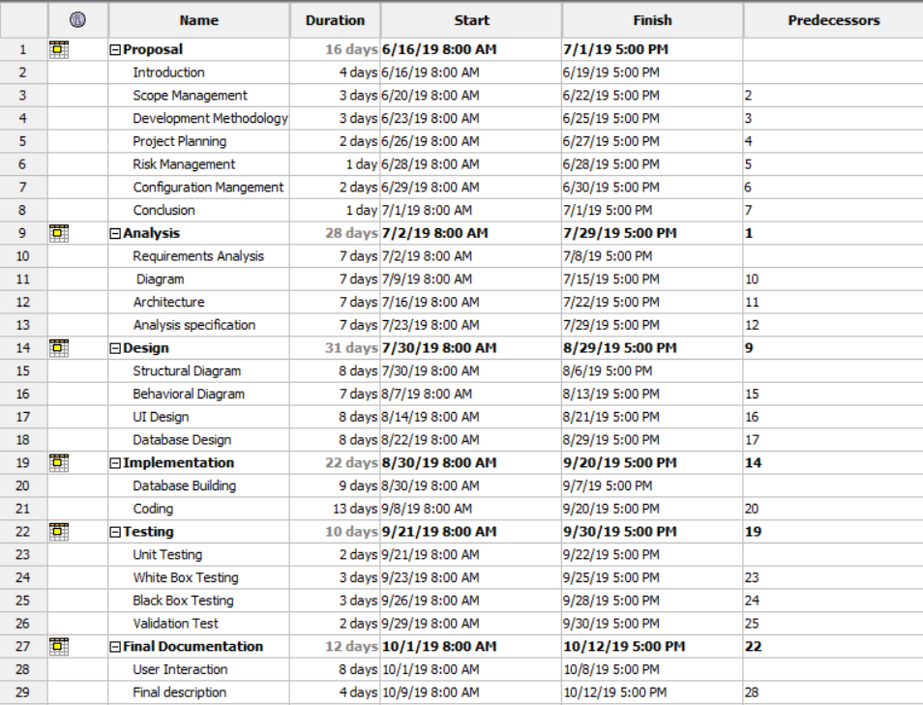

Figure 5 Scheduling of the project

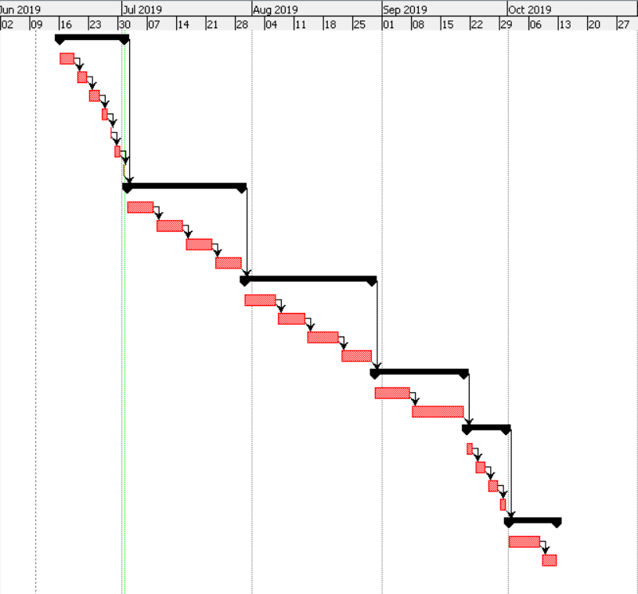

Figure 6 Gantt Chart

# Chapter5:

## 5.1: Risk Management:

Risk Management is the route toward perceiving, reviewing and controlling threats to an affiliation's earnings and capital. These threats, or perils, could start from a wide variety of sources, including budgetary helplessness, legitimate liabilities, crucial organization errors, disasters and cataclysmic occasions. IT security threats and data related risks, and the peril the board procedures to help them, have transformed into a top requirement for digitized associations. Along these lines, a peril the administrators plan dynamically consolidates associations' strategies for perceiving and controlling risks to its electronic assets, including prohibitive corporate data, a customer's before long conspicuous information and ensured development.

Risk Management is made out of 3 distinct segments for example risk occurring chance, consequences of risk, and sway because of the event of the risks.

|  |  |
| --- | --- |
| **Likelihood** | **Value** |
| Low | 1 |
| Medium | 2 |
| High | 3 |

Table: Likelihood

|  |  |
| --- | --- |
| **Consequence** | **Value** |
| Very low | 1 |
| Low | 2 |
| Medium | 3 |
| High | 4 |
| Very high | 5 |

Table: Consequences

Based on the Turner’s (Turner, 1999) quantitative measure for assessing risk, and based on the guidelines for conduction such assessment provided by Dawson (Dawson, 2015), I‘ve presented below the risk management matrix for my project:

|  |  |  |  |  |  |
| --- | --- | --- | --- | --- | --- |
| **Risk Id** | **Risk** | **Likelihood** | **Consequence** | **Impact** | **Action** |
| 1 | Phishing | 3 | 3 | 9 | Use of anti-malware and spam filtering |
| 2 | Server Failure | 2 | 4 | 8 | Regular system maintenance and alternate power supply |
| 3 | Improper Project Scheduling | 3 | 3 | 9 | Proper examination at the fundamental stage; before starting the undertaking.  Coding time, support time, testing time should be insisted as first. |
| 4 | Time and Budget Shortage | 2 | 5 | 10 | Managing the time in proper way and the money |
| 5 | Hardware Crash | 1 | 5 | 5 | Backup |

# Chapter 6: Configuration Management:

## 6.1:

Configuration management makes a distinction organizations to supervise, organize, and control the changes inside the records, codes, and other substances in the midst of the SDLC. It is truncated as the SCM handle. It focuses to control taken a toll and work effort included in making changes to the code. The fundamental objective is to amplify effectiveness with unimportant botches.

* Changes in need, course of action, budget, and arrange need to be obliged.
* There are numerous individuals working on computer program which is persistently updating.
* Computer program need to able to run on distinctive machines and Working Frameworks
* Helps to have a coordination between stakeholders
* It is useful to control the costs included in making changes to a system.

In spite of different significance, Version Control is the basic incorporate that we use.

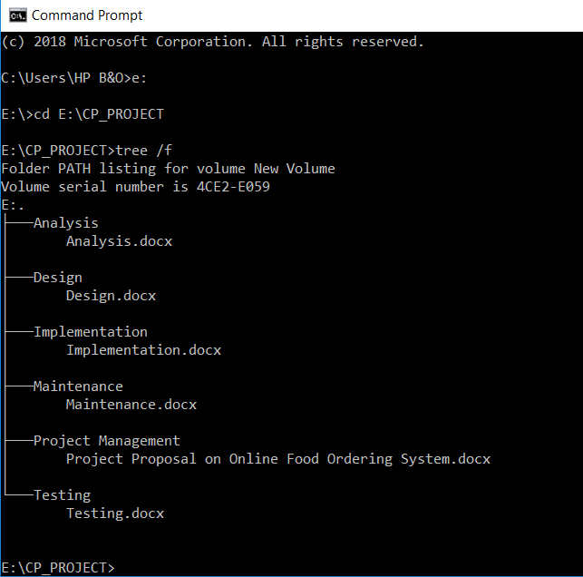

Figure 7 : Tree Structure of the Folder structure

Github: It is the favored Version control Platform of most engineers, since it has different focal points over the other frameworks accessible.

GIT is the tool that will be utilizing for managing course of action. It might be a free and open source device which makes a distinction adjustment control. It is sketched out to handle all sorts of ventures with speed and proficiency.

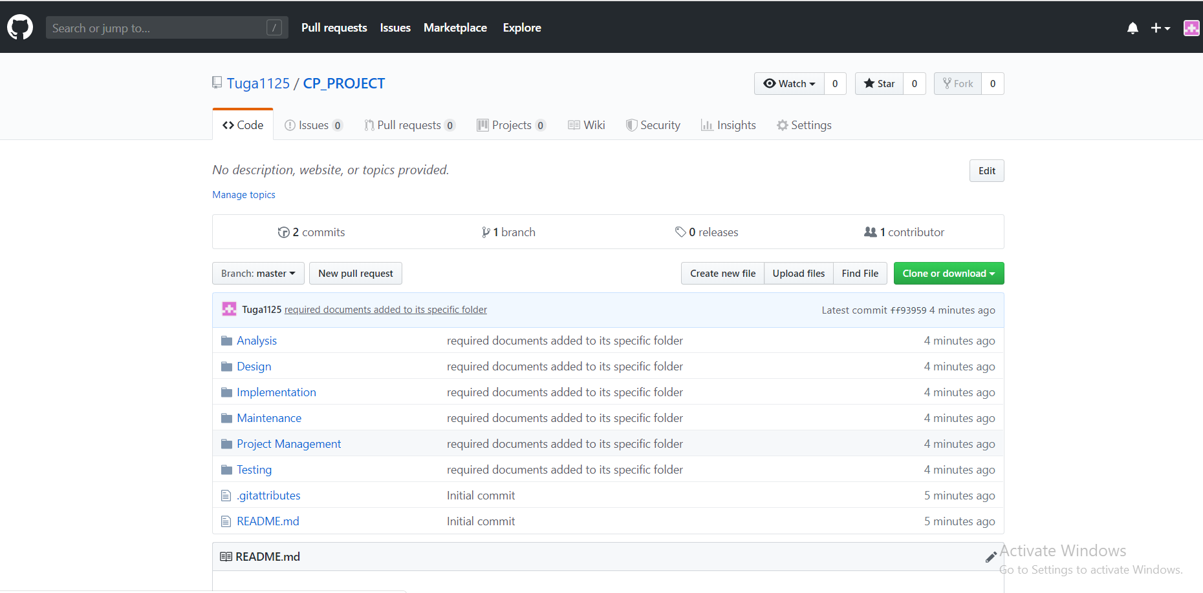

Figure 8 Folder Structure in Github Drive

# Chapter 7: Conclusion:

To conclude, the online ordering system project is developed with the above mentioned features, aims and objectives. It follows the Waterfall methodology to develop the software whose steps are; Planning, Analysis, Design, Implementation, Testing and Maintenance. MVC pattern is used to implement the software. 3-tier architecture is a system architecture applied for the development of this platform. WBS i.e Work Breakdown Structure is created to break the working procedures of a system. It is followed by Milestone, which is a specific point in a development that is displayed with the help of a Gantt Chart, which is made with the help of Project Libre. Likewise, the risks are listed along with its likelihood, consequences, impact and the actions to take when this threat occurs. For the configuration management, Tree structure is made with the Command Line that is shown in the figure. The file is finally uploaded in the Github, which is used to handle the projects efficiently.

In this way, the proposal is documented for the online food ordering system.

# References:

1. SearchSoftwareQuality. (2019). What is waterfall model? - Definition from WhatIs.com. [online] Available at: https://searchsoftwarequality.techtarget.com/definition/waterfall-model [Accessed 20 Jun. 2019].

2. www.tutorialspoint.com. (2019). SDLC Waterfall Model.[online] Available at: https://www.tutorialspoint.com/sdlc/sdlc_waterfall_model.htm [Accessed 21 Jun. 2019].

3. Techopedia.com. (2019). What is Three-Tier Architecture? - Definition from Techopedia.[online] Available at: https://www.techopedia.com/definition/24649/three-tier-architecture [Accessed 23 Jun. 2019].

4. Workbreakdownstructure.com. (2019).What is a Work Breakdown Structure (WBS) [online] Available at: https://www.workbreakdownstructure.com/ [Accessed 24 Jun. 2019].

5. SearchCompliance. (2019).What is risk management? - Definition from WhatIs.com.[online] Available at: https://searchcompliance.techtarget.com/definition/risk-management [Accessed 25 Jun. 2019].

6. SearchITOperations. (2019). What is configuration management (CM)? - Definition from WhatIs.com. [online] Available at: https://searchitoperations.techtarget.com/definition/configuration-management-CM [Accessed 26 Jun. 2019].

7. Merriam-webster.com. (2019). Definition of MILESTONE. [online] Available at: https://www.merriam-webster.com/dictionary/milestone [Accessed 27 Jun. 2019].